Heaven’s Life is Our Guide
Rajshahi University of Engineering & Technology
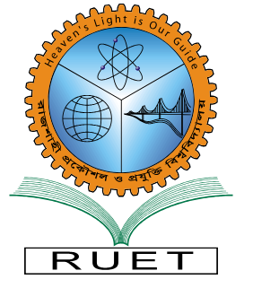

Department of
Electrical & Computer Engineering

Project Title: Smart Home Automation – IoT Dwelling

Course Code: ECE-2200
Course Title: Electronic Shop Practice

Submitted To:  Md. Omaer Faruq Goni  Assistant Professor  Dept of ECE, RUET | Submitted By:  Osman Goni  Roll: 2210009  &  Md. Shadid Hasan Niloy Akanda  Roll: 2210024  Semester: 2nd Year Even

